St. James Priory Project is a unique venture in Bristol City Centre.

It is based on the site of St James Priory, which is the oldest building in Bristol dating from 1129.

The Charity aims to support people with a history of homelessness who have a substance dependency.

The Project supports vulnerable people.

It also provides support and advice for individuals and families who are experiencing problems as a consequence of addiction.

The Charity is committed to working collaboratively with individuals in order to empower them to achieve a full and sustainable recovery from addiction.

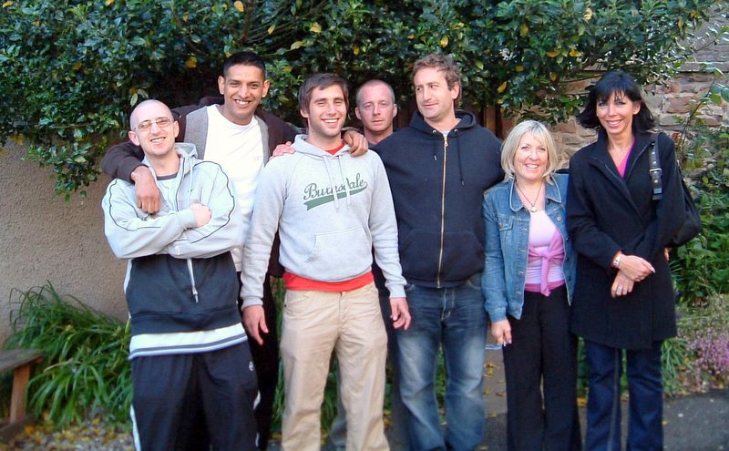

MAKE ROOM ……

IN YOUR LIFE ……

FOR YOUR LIFE !!

Referrals can be made directly by Agencies and individuals.

References will be required.

No pets are allowed.

No cars are allowed.

For further information and

application details please contact:

St. James House
St. James Priory Project
Whitson Street
Bristol
BS1 3NZ

Tel: 0117 9299100
Fax: 0117 9225980

E.Mail : info@stjamespriory.org.uk

The Queen’s Golden
Jubilee Award 2003

January 2022

___

ST. JAMES HOUSE

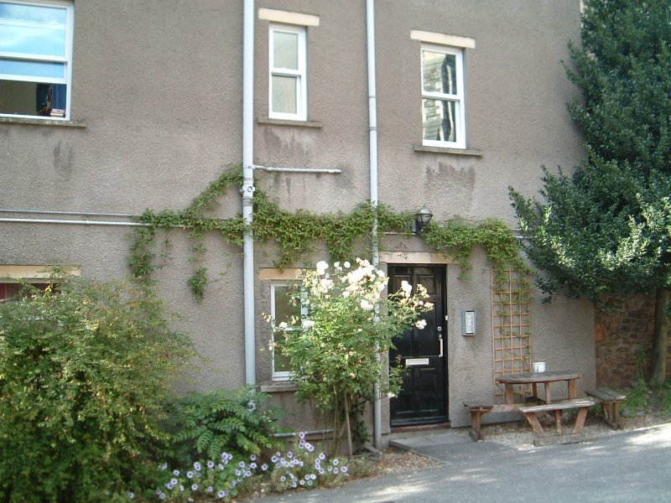

Independent
Supported Housing
for People in
Recovery from Addiction

www.stjamespriory.org.uk

Registered Charity Number 1104408
Registered Company Number 04730515

St. James House opened in June 1999.

It offers ‘Third Stage’ supported housing for people with a housing need many of whom have experienced First Stage and Second Stage treatment for addiction. A commitment to maintaining abstinence from all mood altering substances is a requirement for admission.

The House provides supported housing for people who are in recovery. 10 bed sits are available with shared kitchen, dining and laundry areas.
Support will be minimal – 1 group per week and individual support to meet individual needs.

The emphasis is on encouraging individuals to establish structure and routines, including voluntary work and education, to underpin an abstinence based lifestyle.

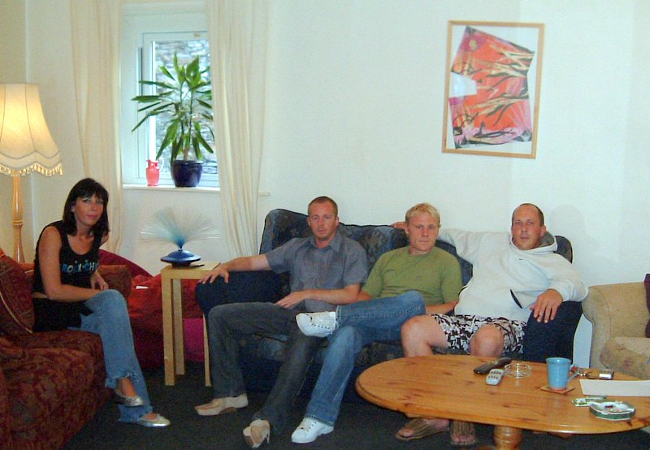

Tenancies are available for up to 24 months. Tenancy agreements will include a clause insisting on abstinence from all mood altering substances. Tenants will be expected to take individual responsibility for their own room and also, collectively, for communal areas.

Housing Benefit and a contribution from residents for service charges meet rent costs.
SERVICE AIMS
To provide good quality accommodation, support and care to single people who have a history of homelessness and who are in recovery from addiction.

SERVICE OBJECTIVES
- To provide accommodation that is safe and supportive.
- To provide a flexible and appropriate level of support to enable tenants to maintain their tenancy and progressively develop a settled way of life.
- To work with tenants to recognise and support their abstinent lifestyle.
- To encourage and assist tenants to address their own primary and secondary health needs.
- To enable tenants to acquire and develop life and social skills necessary to manage their own tenancies.
- To encourage and assist tenants to develop social networks through active day programmes and to access community resources.
- To encourage tenants to seek voluntary work as appropriate.
- To signpost residents to other agencies as necessary.
- To enable clients to maintain or resume family and other significant relationships where appropriate.
- To enable tenants to explore move-on options when ready.

LAPSE AND RELAPSE POLICY
Alcohol & drug dependencies are viewed as “relapsing conditions”.
A Lapse or Relapse is a common outcome of interventions with people with addictions on the road to a long term abstinence based recovery.

Research into relapse rates for people who have completed residential treatment suggest that the rate of relapse can be high.

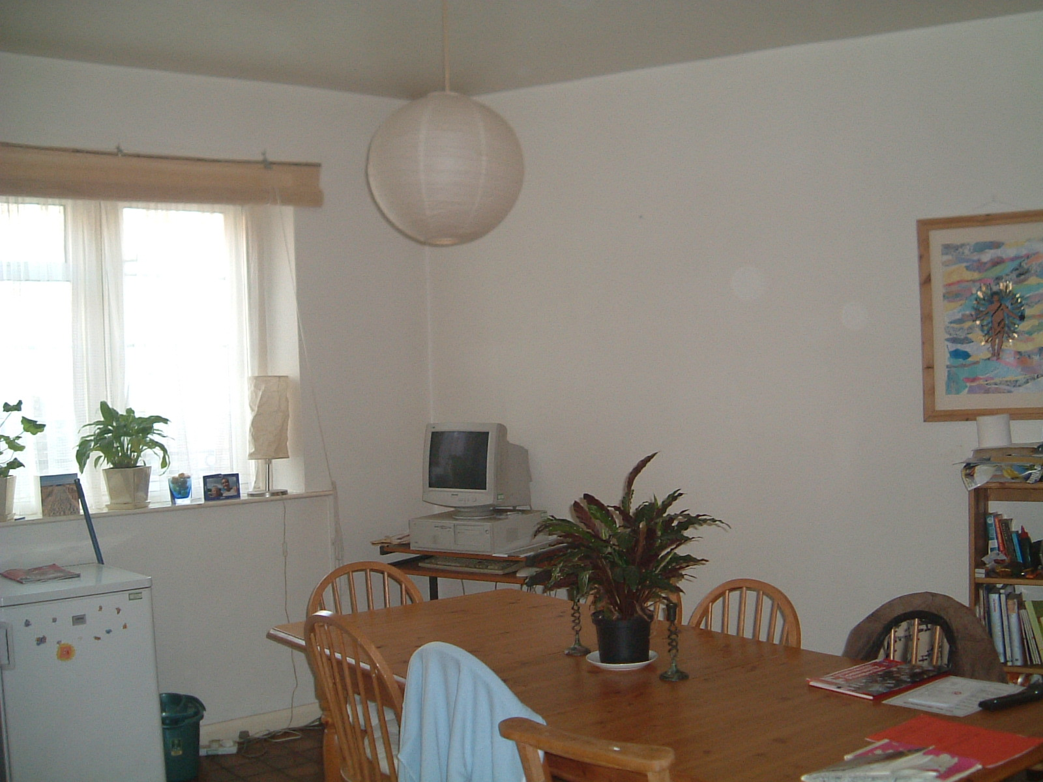

Just because lapse/relapse figures are high does not mean that it will happen to you. To be forewarned is to be forearmed. To prevent a lapse developing into a full blown relapse is one of the main objectives of relapse prevention.

St. James House is a drug and alcohol free zone. However, lapses may occur.

The policy in the event of a lapse is that each case will be dealt with according to the circumstances of the lapse. We aim to work with individuals who lapse. Residents at St. James House will be involved in the process but the final decision will be that of the Manager.

